Chapter 7, Problem 54.

Obtain the inductor current for both t < 0 and t > 0 in each of the circuits in
Fig. 7.120.

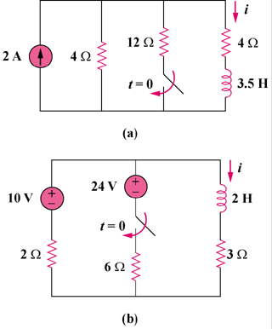

Figure 7.120
For Prob. 7.54.

